PRACTICAL-4

NAME-PATEL DHARA JANAKBHAI

ROLL N0-141

WRITING EMAIL

**Email Writing**

Email stands for electronic mail. It is the easiest and the cheapest way of [communication](https://www.toppr.com/guides/business-studies/directing/communication/). It is used in formal, semi-formal as well as an informal way of expression or writing.

**Browse more Topics under Writing Formal Mails**

* [Definition, Effective Mails](https://www.toppr.com/guides/business-correspondence-and-reporting/writing-formal-mails/definition-effective-mails/)
* [Essential Elements of Mails](https://www.toppr.com/guides/business-correspondence-and-reporting/writing-formal-mails/essential-elements-of-mails/)

**Categories of Email Writing**

Emails are of three types

* Semi-Formal email
* Formal email
* Informal email

**Email Writing Format**

The email writing format is the same for each of the categories. Though the choice of words and language differ depending upon the type of email. One can use friendly and casual language in[informal emails](https://www.toppr.com/guides/english/writing/informal-letters/). The language used in formal emails should be professional, clear, and formal. The email writing format is

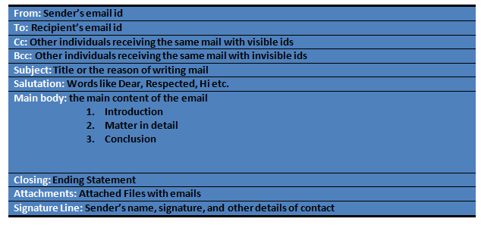

Let us discuss each type of email writing format.

**A Sample of Informal Email Writing Format**

An email written for any friends, family members or relatives comes under this category. Use of polite, friendly and casual words along with proper greetings and closings are some of the rules of the informal emails.

Sample

Suppose you have to write an email to your friend inviting him or her to your birthday party.

To: XYZ

CC/BCC:

Subject: Invitation to a birthday party

Hi XYZ!

Hope this mail finds you in the best of your time. I am very happy to invite you to my birthday party on Nov 03 at ABC Hotel from 7:00 pm to 10:00 pm. The theme of the birthday party is ‘Pirate of the Caribbean”.

It would be great if you come and join us at the party. We will have a great time and fun together.

See You Soon

LMN

**A Sample of Semi-formal Email Writing Format**

An email written for any teammates or colleague is the semi-formal email. One can use friendly language but have to maintain the limit and the decency. The length, proper greetings and closing and clarity are some of the rules of the semi-formal emails.

Sample

Writing a letter to inform your classmates regarding intra-college quiz competition.

To: XYZ

CC/BCC:

Subject: Intra-college Quiz Competition.

Hello Everyone!

This is to inform you guys that an intra-college quiz competition is going to be held in our college on Nov 25 from 11:30 am in Hall – 01.

Everyone is therefore asked to take part in the competition so that our department can win.

For further queries, feel free to contact me.

Thanks

LMN

(Class Representative)

**A Sample of Formal Email Writing Format**

An email written for business communication or professional use comes under this category. The email written for any government department, school authority, company or any officers are the formal emails. Use of polite and formal words, the reason for writing mail, clarity, proper greeting and closing are some of the rules of the formal email.

Sample

A mail for resignation.

To: XYZ

CC/BCC:

Subject: Resignation Letter

Dear Sir,

Please accept this mail as a notice that I am leaving my position with this organization. As per the norm of the company I’ve to give a month notice before resigning. I hope you will get a good replacement for me within this time period.

I really appreciate the opportunities that I have been given to me to help me grow. Wish you and the company the best in the future.

Please let me know what to expect as far as my final work schedule and the employee benefits. Please let me know in case of any assistance for the above.

Kindly look into the matter.

Thanks and Regards

LMN

(Project Head)